**Registered Reports**

**Author Guidelines**

These guidelines have been adapted from templates made available under Creative Commons CC0 license through the Center for Open Science (<https://osf.io/pukzy/>).

*Registered Reports* are a form of empirical article in which the methods and proposed analyses are pre-registered and reviewed prior to research being conducted. This format is designed to minimise bias while also allowing complete flexibility to conduct exploratory (unregistered) analyses and report serendipitous findings.

The cornerstone of the Registered Reports format is that a significant part of the manuscript will be assessed prior to data collection, with the highest quality submissions accepted in advance. Initial submissions will include a description of the key research question and background literature, hypotheses, experimental procedures, analysis pipeline, a statistical power analysis (or Bayesian equivalent), and pilot data (where applicable).

Initial submissions will be triaged by an editorial team for suitability. Those that pass triage will then be sent for in-depth peer review (Stage 1). Following review, the article will then be either rejected or accepted in principle for publication. Following in principle acceptance (IPA), the authors will then proceed to conduct the study, adhering exactly to the peer-reviewed procedures. When the study is complete the authors will submit their finalised manuscript for re-review (Stage 2) and will upload their stimuli, data, and analysis code to a publicly accessible archive. Pending quality checks and a sensible interpretation of the findings, the manuscript will be published regardless of the results.

**The review process for *Registered Reports***

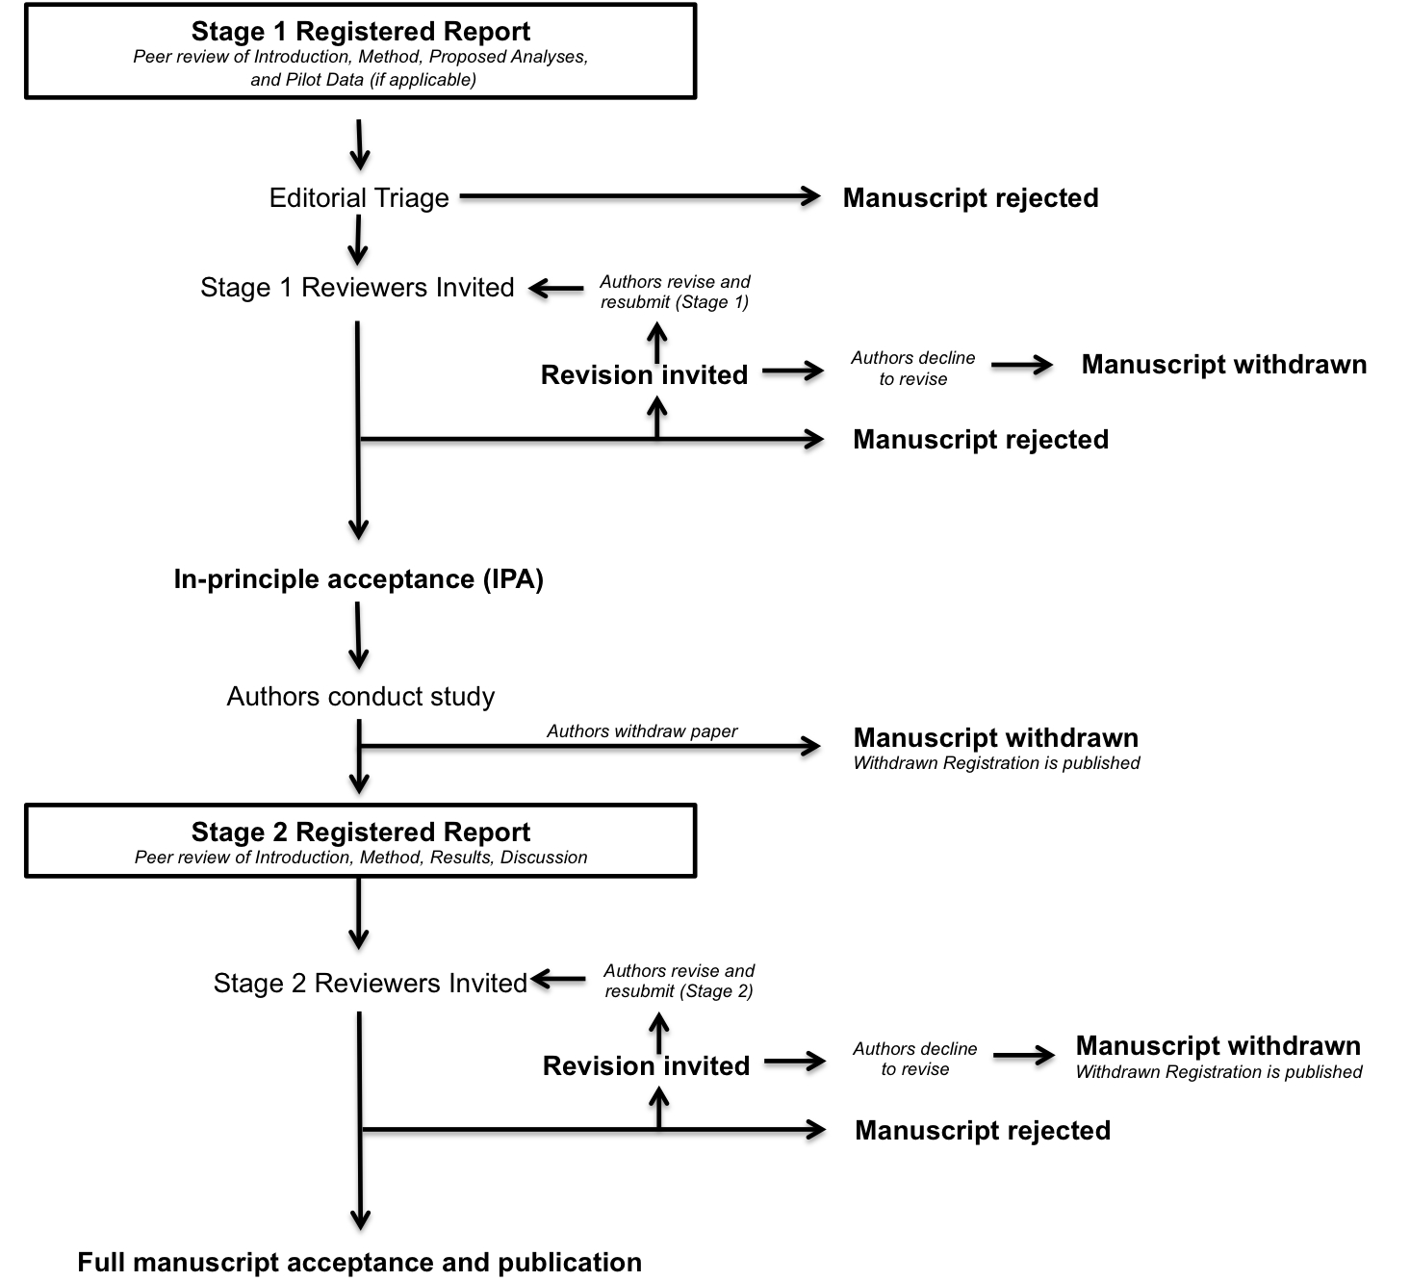

**STAGE 1: INITIAL MANUSCRIPT SUBMISSION AND REVIEW**

Stage 1 submissions should include the manuscript (details below) and a brief cover letter.

The Stage 1 cover letter should include:

* A brief scientific case for consideration. We welcome novel studies as well as replications. In each case, there must be a strong rationale for the work on par with our high standards for theoretical import.
* A statement confirming that all necessary support (e.g. funding, facilities) and approvals (e.g. ethics) are in place for the proposed research. Manuscripts will generally be considered only for studies that are able to commence immediately.
* An anticipated timeline for completing the study if the initial submission is accepted.
* A statement confirming that the authors agree to share their raw data, any digital study materials, and analysis code in line with our data sharing policy.
* A statement confirming that, following Stage 1 *in principle acceptance*, the authors agree to register their approved protocol on the Open Science Framework (<https://osf.io/>) until submission of the Stage 2 manuscript.
* A statement confirming that if the authors later withdraw their paper, they agree to the Journal publishing a short summary of the pre-registered study under a section *Withdrawn Registrations*.

*Manuscript preparation guidelines – Stage 1*

Initial Stage 1 submissions should include the following sections:

**Abstract**. The abstract should include a summary of research to be conducted and proposed analysis methods. The abstract will be updated at Stage 2 following data collection.

**Introduction.** Review of the relevant literature that motivates the research question and a full description of the experimental aims and hypotheses. Following IPA, the Introduction section cannot be altered apart from correction of factual errors, typographic errors and altering of tense from future to past.

**Methods.** The methods section should include sections for Participants, Design, Stimuli, Procedures, and analysis plan. It should offer a description of experimental procedures that is sufficiently detailed to allow another researcher to repeat the methodology exactly, without requiring further information. These procedures must be adhered to exactly in the subsequent experiments or any Stage 2 manuscript can be rejected.

* Include a full description of proposed sample characteristics, including criteria for data inclusion and exclusion (e.g. outlier extraction). Procedures for objectively defining exclusion criteria due to technical errors or for any other reasons must be specified, including details of how and under what conditions data would be replaced.
* In many areas of language and memory research it will normally be necessary to include the actual stimuli to be used (as opposed to a description of how they will be selected). This will allow authors to get feedback on the adequacy of stimuli prior to running the study.
* Proposed analysis pipeline, including all preprocessing steps, and a precise description of all planned analyses, including appropriate correction for multiple comparisons. Any covariates or regressors must be stated. Where analysis decisions are contingent on the outcome of prior analyses, these contingencies must be specified and adhered to. Only pre-planned analyses can be reported in the main Results section of Stage 2 submissions. However, unplanned exploratory analyses will be admissible in a separate section of the Results (see below).
* Stage 1 submissions must justify both the number of participants and the number of trials by showing that the planned experiments exceed the traditional minimum standards for statistical power (power >= 0.80 with alpha =.05) for any tests, including interactions. We suggest that authors study recent literature on power in language and memory experiments carefully (e.g. Brysbaert & Stevens, 2018; Brysbaert, 2019), in particular with respect to power issues around [interactions](http://daniellakens.blogspot.com/2020/03/effect-sizes-and-power-for-interactions.html), and with respect to the role of numbers of items in statistical power. Effect size estimates should be fully justified based on previous literature being replicated, taking into account the possibility that previous effect sizes may have been inflated due to publication bias. In the case of highly uncertain effect sizes, a variable sample size and interim data analysis is permissible but with inspection points stated in advance, [appropriate Type I error correction for ‘peeking’ employed](http://onlinelibrary.wiley.com/doi/10.1002/ejsp.2023/abstract), and a final stopping rule for data collection outlined.
* We welcome the use of Bayesian statistical methods. If the primary analysis is Bayesian, power calculations should demonstrate the ability of the study, with its planned number of participants and items, to produce a Bayes factor that convincingly favors either the experimental hypothesis or the null hypothesis (e.g., Kruschke & Liddell, 2018 Schönbrodt & Wagenmakers, 2018).  While we do not dictate the specific Bayes factor that should be regarded as 'convincing', we encourage authors to power their studies amply, to a higher standard than typical empirical studies. If the authors choose to use a Bayesian stopping rule for determining the number of participants (e.g., Rouder, 2014), this should be specified in advance. While we welcome analyses that compute Bayes factors, we also welcome Bayesian parameter estimation establishing a posterior distribution over the effect size for the critical effects; in this case, instead of traditional power analysis the Stage 1 submission should demonstrate the ability of the study to achieve a specified level of precision in estimating the critical parameters (see Kruschke & Liddell, 2018, pp. 201-203). In all cases, Stage 1 submissions that plan Bayesian analysis should provide the same level of detail as required for frequentist analysis, including detailed specification of the parameters of the Bayesian models, and specification of prior distributions for these parameters.
* Full descriptions must be provided of any outcome-neutral criteria that must be met for successful testing of the stated hypotheses. Such quality checks might include the absence of floor or ceiling effects in data distributions, positive controls, or other quality checks that are orthogonal to the experimental hypotheses.
* Pilot data may be included but are optional. Pilot data can help to establish proof of concept, effect size estimations, or feasibility of proposed methods. Any pilot experiments will be published with the final version of the manuscript and will be clearly distinguished from data obtained for the pre-registered experiment(s).

Stage 1 submissions that are judged by the Editorial team to be of sufficient quality and within journal scope will be sent for in-depth peer review. In considering papers at the registration stage, reviewers will be asked to assess:

1. The importance of the research question(s).
2. The logic, rationale, and plausibility of the proposed hypotheses.
3. The soundness and feasibility of the methodology and analysis pipeline (including statistical power analysis).
4. Whether the clarity and degree of methodological detail is sufficient to exactly replicate the proposed experimental procedures and analysis pipeline.
5. Whether the authors have pre-specified sufficient outcome-neutral tests for ensuring that the results obtained can test the stated hypotheses, including positive controls and quality checks.

Following Stage 1 peer review, manuscripts will be rejected outright, offered the opportunity to revise, or accepted. Proposals that meet the highest standards of importance and scientific rigour will be issued an *in principle acceptance* (IPA), indicating that the article will be published pending completion of the approved methods and analytic procedures, passing of all pre-specified quality checks, and a defensible interpretation of the results. Stage 1 protocols are not published by the journal following IPA. Instead they should be registered by the authors on the OSF until Stage 2, and then integrated into a single completed article following approval of the final Stage 2 manuscript. The Stage 2 manuscript will include a link to the approved Stage 1 protocol for transparency.

**Authors are reminded that any deviation from the stated experimental procedures, regardless of how minor it may seem to the authors, could lead to rejection of the manuscript at Stage 2.** In cases where the pre-registered protocol is altered after IPA due to unforeseen circumstances (e.g. change of equipment or unanticipated technical error), the authors must consult the Editor immediately for advice, and prior to the completion of data collection. Minor changes to the protocol may be permitted per editorial discretion. In such cases, IPA would be preserved and the deviation reported in the Stage 2 submission. If the authors wish to alter the experimental procedures more substantially following IPA but still wish to publish their article as a Registered Report then the manuscript must be withdrawn and resubmitted as a new Stage 1 submission. Note that all registered analyses must be undertaken, but additional unregistered analyses can also be included in a final manuscript in a separate section titled ‘*Exploratory Analyses*’ (see below).

**STAGE 2: FULL MANUSCRIPT REVIEW**

Once the study is complete, authors prepare and resubmit their manuscript for full review.

**Cover letter**. The Stage 2 cover letter must confirm:

* That no data for any pre-registered study was collected prior to the date of IPA.
* That the manuscript includes a “Registrations and Data Availability” section placed just prior to the Methods. This section should include a link to the registered Stage 1 manuscript on the OSF, as well as a link to a public archive containing stimuli, data, analysis code, and any computational models.

**Data availability**. Authors must comply with our data sharing policy (<https://www.sciencedirect.com/science/article/abs/pii/S0749596X18300883>). Data files should be time stamped, allowing confirmation that data were collected *after* IPA and not before. Other than pre-registered and approved pilot data, no data acquired *prior* to the date of IPA is admissible in the Stage 2 submission. Registered Report submissions should provide an example of the very best practice in the area of data sharing, with clearly labelled files and well commented code to enable readers to reproduce findings. The Stage 2 manuscript must include a section titled “Registrations and Data Availability” that includes a link to the approved Stage 1 manuscript and a link to stimuli, data, analysis code, and any computational models.

**Abstract.** The abstract should be updated to include findings and interpretation.

**Introduction and Methods**. These sections should not change except to rectify any factual errors or typos, and to change the tense. Please use track changes to highlight any changes to the approved Stage 1 submission.

**Results.**  This section should include the outcome of all registered analyses. If authors wish to include unregistered analyses, these should be clearly labelled in a section titled “Exploratory Analyses”; authors should take care around the weight given to such analyses in drawing conclusions. If using NHST please include exact p-values and effect sizes for all tests; if using Bayesian methods, include Bayes factors and/or, where appropriate, representations of posterior distributions including HDIs.

**Discussion**. This section should interpret the results and offer conclusions as to the status of the finding being replicated.

The resubmission will most likely be considered by the same reviewers as in Stage 1, but could also be assessed by new reviewers. In considering papers at Stage 2, reviewers will be asked to decide:

1. Whether the data are able to test the authors’ proposed hypotheses by satisfying the approved outcome-neutral conditions (such as quality checks, positive controls)
2. Whether the Introduction, rationale and stated hypotheses are the same as the approved Stage 1 submission (required)
3. Whether the authors adhered precisely to the registered experimental procedures
4. Whether any unregistered *post hoc* analyses added by the authors are justified, methodologically sound, and informative; and whether they are appropriately labelled as *Exploratory*.
5. Whether the authors’ conclusions are justified given the data

**Editorial decisions will not be based on the perceived importance, novelty or conclusiveness of the results.**

**MANUSCRIPT WITHDRAWAL AND WITHDRAWN REGISTRATIONS**

It is possible that authors with IPA may wish to withdraw their manuscript following or during data collection. Possible reasons could include major technical error, an inability to complete the study due to other unforeseen circumstances, or the desire to submit the results to a different journal. In all such cases, manuscripts can of course be withdrawn at the authors’ discretion. However, the journal will publicly record each case in a section called *Withdrawn Registrations*. This section will include the authors, proposed title, the abstract from the approved Stage 1 submission, and brief reason(s) for the failure to complete the study. Partial withdrawals are not possible; i.e. authors cannot publish part of a registered study by selectively withdrawing one of the planned experiments. Such cases must lead to withdrawal of the entire paper. Studies that are not completed by the agreed Stage 2 submission deadline (which can be extended in negotiation with the editorial office) will be considered withdrawn and will be subject to a Withdrawn Registration.